2014ICJLE徵稿延期資訊
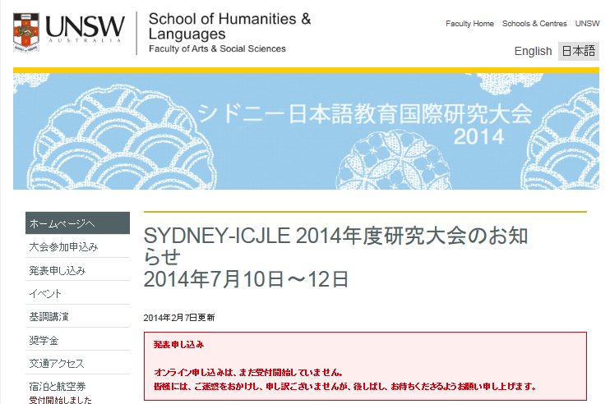
https://icjle2014.arts.unsw.edu.au/jp/

